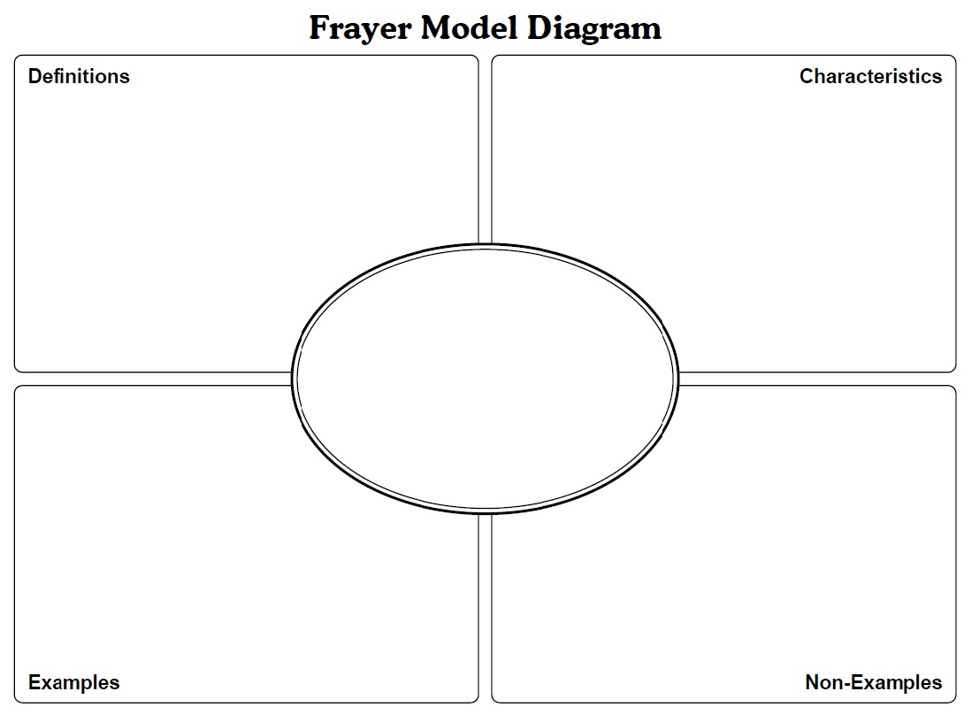
Unit 8 Name: __________________________________________________ Date: _________________________ Period: _____
ruled by an absolute monarch

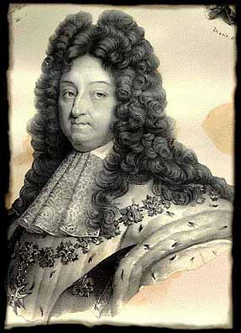
Absolute Monarch Case Study: Louis XIV of France
Using the space below, list reasons why Louis XIV is considered an absolute monarch.
Be prepared to discuss these reasons the following class period.
Recommended Resources:
- goo.gl/BxRcTb
- goo.gl/qc5kG8
- goo.gl/yljZdQ

Political –

Economic –

Social –

Religious –

Cultural –

Other -

