Pre-AP World History
Clear Springs High School, Course Syllabus

Instructor: Mrs. Kelly Chase Room: 1121
Contact information: KChase@ccisd.net Conference: 8:16 AM — 9:05 AM (2nd period)
281-284-1300 x 21303 Tutorials: Tuesday and Thursday 2:30-3:15 pm

Course Description
Pre-AP World History will be a challenging course, and it will cover a wide range of human history and development. Students are expected to meet the high standard of academic excellence set before them. Classroom discussions play an important role in this course, as world history, both ancient and modern, are tied to current issues relevant to the student. Students must enter each class period prepared; keeping up with the assigned reading is essential to success in this course. Please refer to the World History Year at a Glance for pacing guide.

Activities/Projects
In preparation for the AP US History course junior year, class activities include lectures, document and video analysis, independent study assignments, essay composition, and class discussions. Due to the massive extent of material we are required to cover in this course (“from dirt to Obama”), this course moves very quickly and often times, students are expected to attain supplemental information from reading assignments not necessarily discussed or covered during the class period (see Avg. Daily/Weekly Workload).

Grading Criteria
- MAJOR ASSIGNMENTS: Tests, essays, projects, and nine-week assessments will be counted 50% of the student’s grade average.
- DAILY ASSIGNMENTS: Homework, in-class assignments, and quizzes will be counted 45% of the student’s grade average. (Some quizzes will be very short, and will be averaged with similar quizzes before being entered in the grade book.)
- Reading and Writing Assignments— will be counted 5% of the nine-week average per CCISD District Policy

Avg. Daily/Weekly Homework Load
Students are expected to read from the online textbook at home to supplement lectures and activities from class. On average, these reading assignments are 3-8 pages a night, approximately a chapter a week. Students will be expected to take notes (we teach and recommend Cornell Notes) over the assigned sections. Students should be prepared for a reading quiz either the morning after the reading was assigned or at the end of a week or a Chapter.

Classroom Expectations
- Be on time, on task, and prepared to learn every day.
- Keep all personal electronics put away. (*see cell phone policy below)
- Be responsible for your own learning.
- Respect the teacher, the classroom, and other students.
- Clean up after yourself. Trash goes in the trashcan, not on the floor.

*Cell Phone Policy: According to school and district policies, cell phones are not allowed out in classrooms unless the teacher gives direct permission. Any cell phones seen out when they are not supposed to be in use will be confiscated and given to the supervising AP. Students should have their laptops available everyday so cell-phone use is not necessary in daily lessons. All devices should remain on silent throughout the day.
Required Materials
I will require you to bring your CHARGED laptop with you to class every day. Yes, we WILL use it for instructional purposes almost every day.

- 1 3-ring binder (2-3” thickness)
- 2 8-pack of dividers (16 total)
- Loose leaf notebook paper, college ruled or wide ruled
- Pens and pencils
- At least 2 different colored highlighters
- Headphones

Assigned Textbook:
Our course textbook this year is available online as a digital resource through ItsLearning. Students will be trained on how to access and use the textbook resources on their laptops. It is the student’s responsibility to request a hard copy of the textbook if they wish to have one for home use; See Mrs. Raska’s secretary in the Freshmen Pod for more information.

Student Organization (Binders):
In an effort to teach organization and responsibility, I require each student to keep and maintain an organized binder of notes for only my class. Every piece of paper I assign in class will be required to be kept in the binder. There will be random binder checks or quizzes throughout the year to make sure that students are held accountable for this requirement. Binder checks or quizzes will be announced no earlier than a week in advance and will be worth multiple daily grades.

Inner-Outer Circles (“IOCs”):
Every student will be required to participate in (and sometimes lead) class discussions in an activity known as an Inner-Outer Circle (“IOC”). These will take place on the day before a Unit Test and will serve as a peer-led review session to prepare for the upcoming exam. Students are expected to both propose questions to the group as well as answer questions proposed by other students. Students will be graded based on their participation in the class discussion.

Current Events Project:
Over the course of the year, you will be required to take part in an ongoing current events project. Each nine weeks you will be finding articles from a newspaper that discusses something significant that is going on today. Toward the end of the school year, you will be using these articles to produce a newscast that recaps all the important news stories of the past school year. Information regarding this project will be handed out to students in the next few days.
Important due dates for this project:
Part I – 1st Nine Weeks due date Sept. 28th
2nd Nine Weeks due date December 2nd
3rd Nine Weeks due date: February 22nd
4th Nine Weeks due date: April 25th
Part II - Final Project due date May 23rd

Make-up Work:
- Make up work is available to all students. Students are responsible for asking teachers for the makeup work upon returning to class. Students shall receive credit for satisfactory makeup work after an absence, but may receive a zero for any test not made up in the allotted time. Any assignment not turned in within the allotted time falls within the late work guidelines (see below).
- The number of days allowed for makeup work to be completed for full credit will be equal to the number of times a class was missed.
- A student will not on the day of returning to school, be required to take a quiz or test that was announced during his or her absence.
- Makeup work, including tests, may be of an altered version to assess what the student has learned.
- Teachers may assign alternative work to assure that students who have been absent have sufficient opportunity to master the TEKS or to meet subject or course requirements. The assignment shall be based on the instructional objectives for the subject or course and may provide greater depth of subject matter than routine makeup work.
--Cited from Secondary (6-12) Grading and Reporting Procedures
- The easiest place to find makeup work is on Mrs. Chase’s Website (see back page)

Late Work Policy (in accordance with District policy)
One to two days late: 75% of original grade earned.
Three or more days late: A grade of a 0 will be given on the assignment (teacher’s discretion)

Coach Chase’s Website
Disclaimer:
This website will slowly be replaced with CCISD’s new learning platform ItsLearning as I get more training on it.

http://chaseworldhistory.weebly.com

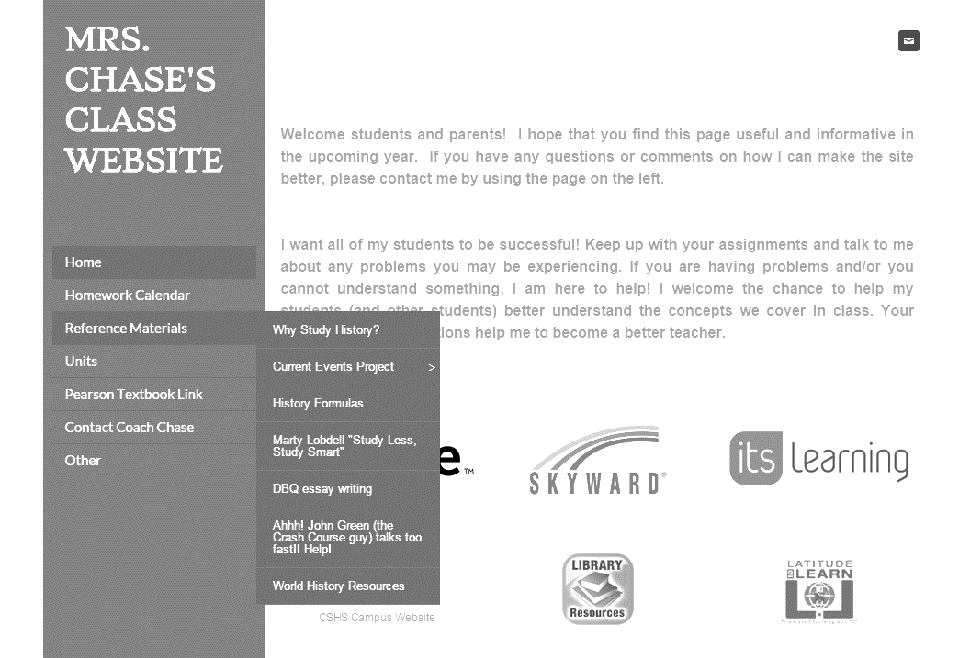
This is the menu bar
Items that will be helpful all year long.
This is the home page

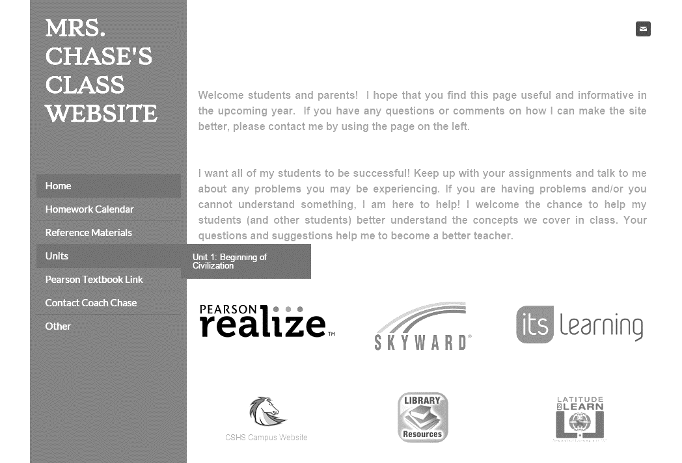
In Class and Homework Assignments will be posted here.
More Units will show up here as the year progresses.
These are all live links for quick access to important places.

